**=DAILY ONLINE ACTIVITIES SUMMARY**

|  |  |  |  |  |  |  |  |
| --- | --- | --- | --- | --- | --- | --- | --- |
| **Date:** | **08/07/2020** | | | | **Name:** | **Pratibha Shetti** | |
| **Sem & Sec** | **IV sem & B section** | | | | **USN:** | **4AL18CS062** | |
| **Online Test Summary** | | | | | | | |
| **Subject** | | **DAA** | | | | | |
| **Max. Marks** | | **30** | | **Score** | | **-** | |
| **Certification Course Summary** | | | | | | | |
| **Course** | **Predictive modeling anlysis** | | | | | | |
| **Certificate Provider** | | | **Greatlearning academy** | **Duration** | | | **5.5hours** |
| **Coding Challenges** | | | | | | | |
| **Problem Statement1:** Given two strings a and b consisting of lowercase characters. The task is to check whether two given strings are anagram of each other or not. An anagram of a string is another string that contains same characters, only the order of characters can be different. For example, “act” and “tac” are anagram of each other. | | | | | | | |
| **Status: Executed** | | | | | | | |
| **Uploaded the report in Github** | | | | **YES** | | | |
| **If yes Repository name** | | | | <https://github.com/pratibhashetty-123/Lockdown-coding-for-python>  <https://github.com/pratibhashetty-123/Lockdown-coding-for-C>  <https://github.com/pratibhashetty-123/Lockdown-coding-java> | | | |
| **Uploaded the report in slack** | | | | **YES** | | | |

Online Test Summary: No internals conducted today.

Online Certification Course Summary:

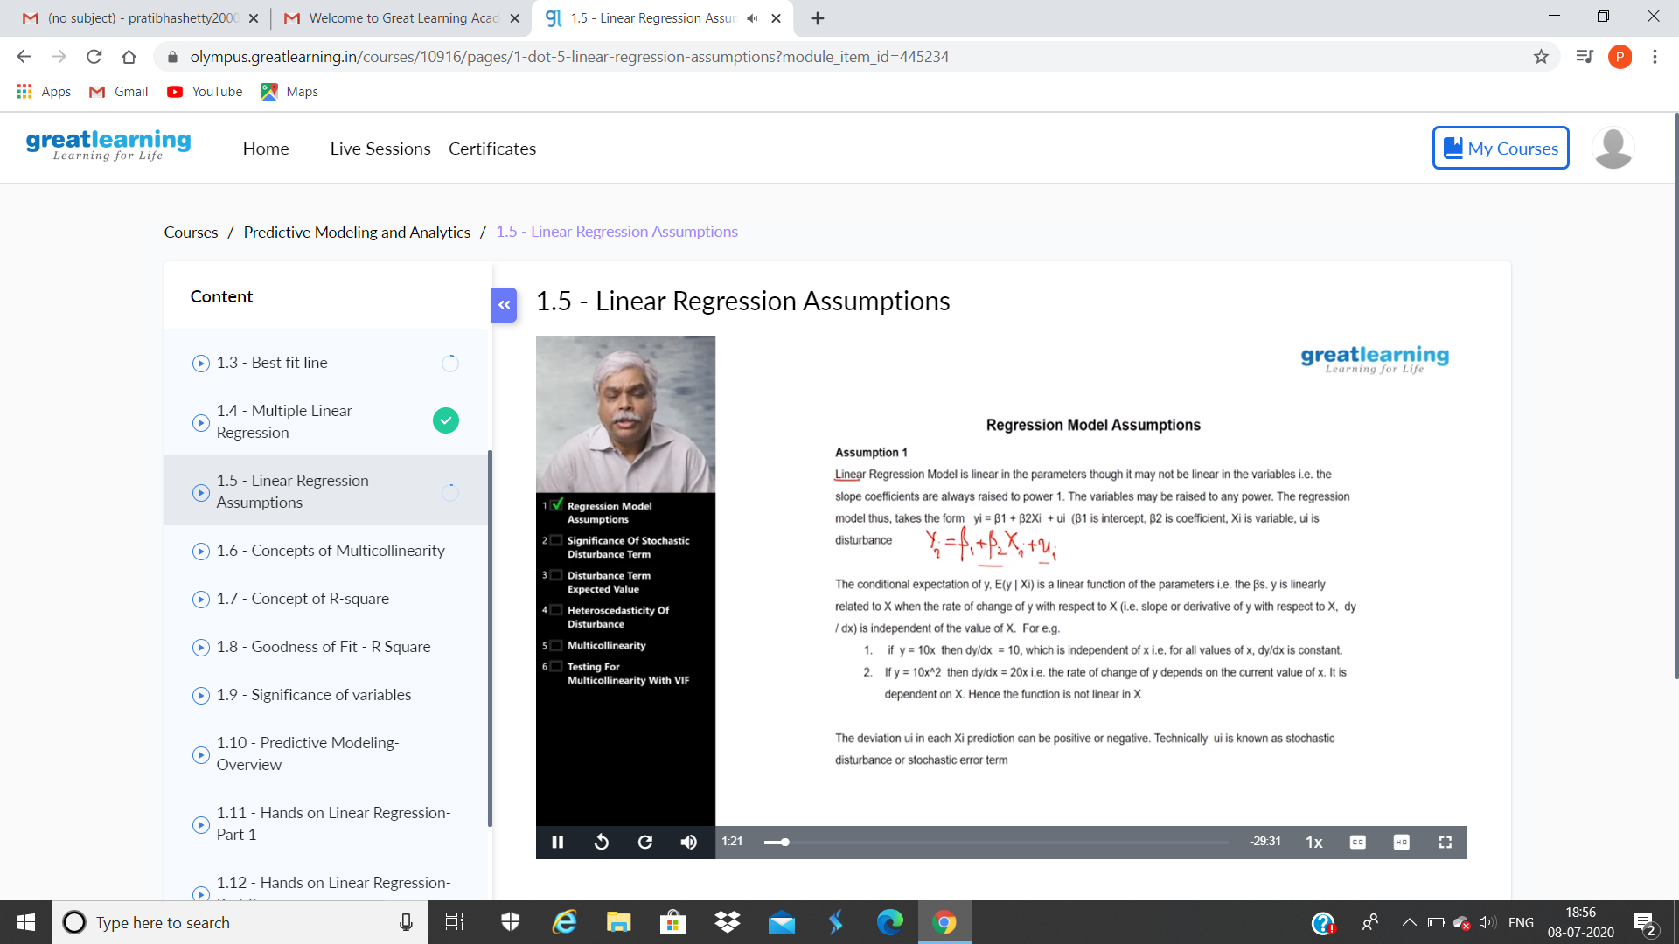

This is the snap shot of Today section

Online Coding Summary: **Today I had received one program from shilp mam CSE Dept. and prof. The program is mentioned above in the coding challenges(pg.01). I have also uploaded it to my Github repository.**

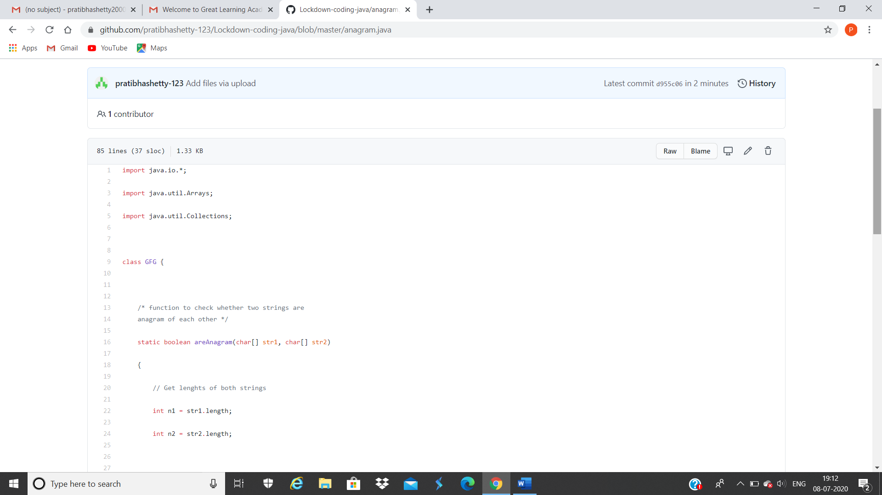

**This is the snap shot of my Github repository** were I have uploaded the code. File name anagram.java